

AP® Physics C
1996 Free response Questions

The materials included in these files are intended for use by AP teachers for course and exam preparation in the classroom; permission for any other use must be sought from the Advanced Placement Program®. Teachers may reproduce them, in whole or in part, in limited quantities, for face-to-face teaching purposes but may not mass distribute the materials, electronically or otherwise. These materials and any copies made of them may not be resold, and the copyright notices must be retained as they appear here. This permission does not apply to any third-party copyrights contained herein.

These materials were produced by Educational Testing Service® (ETS®), which develops and administers the examinations of the Advanced Placement
Program for the College Board. The College Board and Educational Testing Service (ETS) are dedicated to the principle of equal opportunity, and their
programs, services, and employment policies are guided by that principle.

The College Board is a national nonprofit membership association dedicated to preparing, inspiring, and connecting students to college and opportunity.
Founded in 1900, the association is composed of more than 4,200 schools, colleges, universities, and other educational organizations. Each year, the
College Board serves over three million students and their parents, 22,000 high schools, and 3,500 colleges, through major programs and services in
college admission, guidance, assessment, financial aid, enrollment, and teaching and learning. Among its best-known programs are the SAT®, the
PSAT/NMSQT®, and the Advanced Placement Program® (AP®). The College Board is committed to the principles of equity and
excellence, and that commitment is embodied in all of its programs, services, activities, and concerns.

APIEL is a trademark owned by the College Entrance Examination Board. PSAT/NMSQT is a registered trademark jointly owned by the College Entrance Examination Board and the National Merit Scholarship Corporation. Educational Testing Service and ETS are registered trademarks of Educational Testing Service.
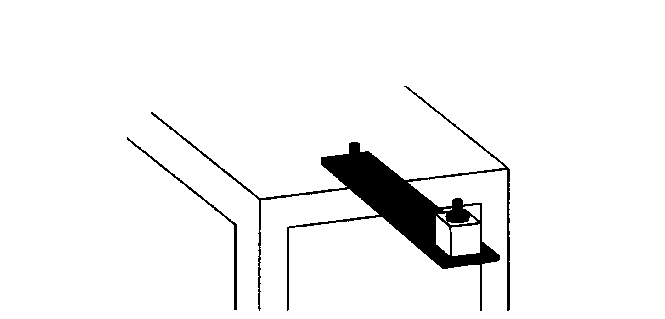
1996M1. A thin, flexible metal plate attached at one end to a platform, as shown above, can be used to measure mass. When the free end of the plate is pulled down and released, it vibrates in simple harmonic motion with a period that depends on the mass attached to the plate. To calibrate the force constant, objects of known mass are attached to the plate and the plate is vibrated, obtaining the data shown below.
a. Fill in the blanks in the data table.
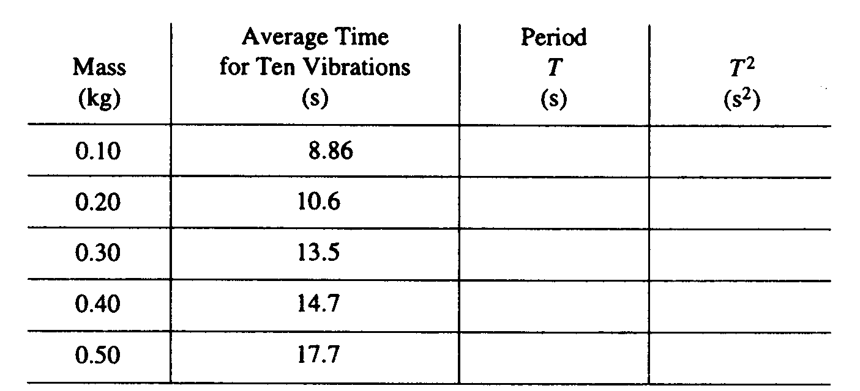
b. On the graph below, plot T² versus mass. Draw on the graph the line that is your estimate of the best straight-line fit to the data points.
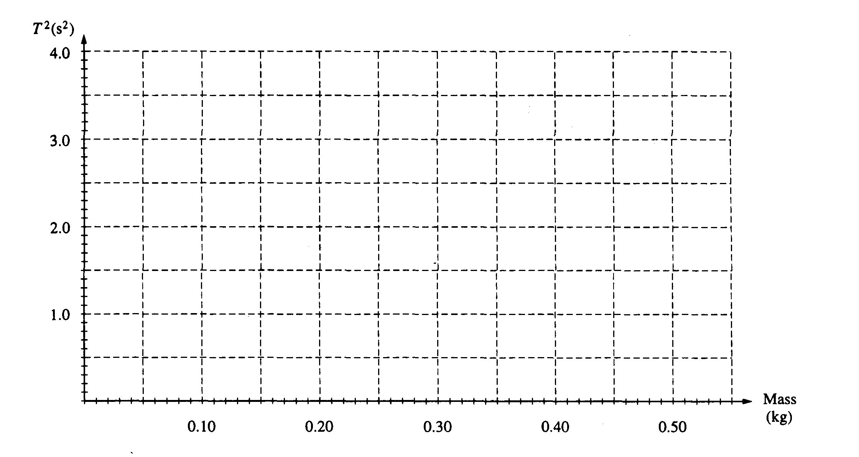
c. An object whose mass is not known is vibrated on the plate, and the average time for ten vibrations is measured to be 16.1 s. From your graph, determine the mass of the object. Write your answer with a reasonable number of significant digits.
d. Explain how one could determine the force constant of the metal plate.
e. Can this device be used to measure mass aboard the space shuttle Columbia as it orbits the Earth? Explain briefly.
f. If Columbia is orbiting at 0.3 x 10⁶ m above the Earth's surface, what is the acceleration of Columbia due to the Earth's gravity? (Radius of Earth = 6.4 x 10⁶ m, mass of Earth = 6.0 x 10²⁴ kg)
g. Since the answer to part (f) is not zero, briefly explain why objects aboard the orbiting Columbia seem weightless.

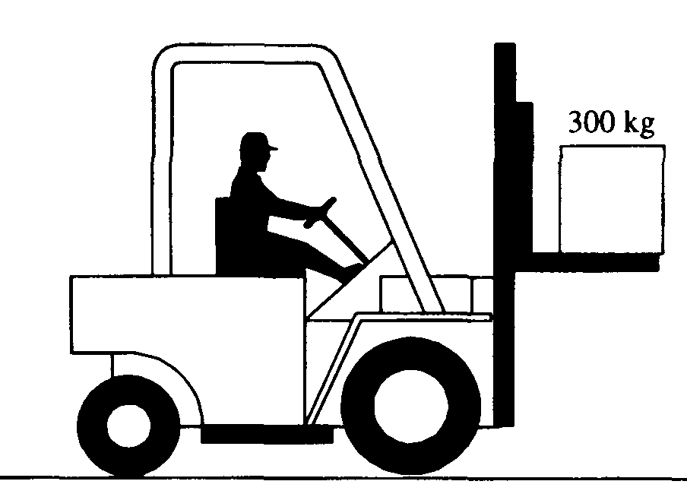
1996M2. A 300-kg box rests on a platform attached to a forklift, shown above. Starting from rest at at time = 0, the box is lowered with a downward acceleration of 1.5m/s²
a. Determine the upward force exerted by the horizontal platform on the box as it is lowered.

At time t = 0, the forklift also begins to move forward with an acceleration of 2 m/s² while lowering the
box as described above. The box does not slip or tip over.
b. Determine the frictional force on the box.
c. Given that the box does not slip, determine the minimum possible coefficient of friction between the
box and the platform.
d. Determine an equation for the path of the box that expresses y as a function of x (and not of t),
assuming that, at time t = 0, the box has a horizontal position x = 0 and a vertical position y = 2 m
above the ground, with zero velocity.
e. On the axes below sketch the path taken by the box
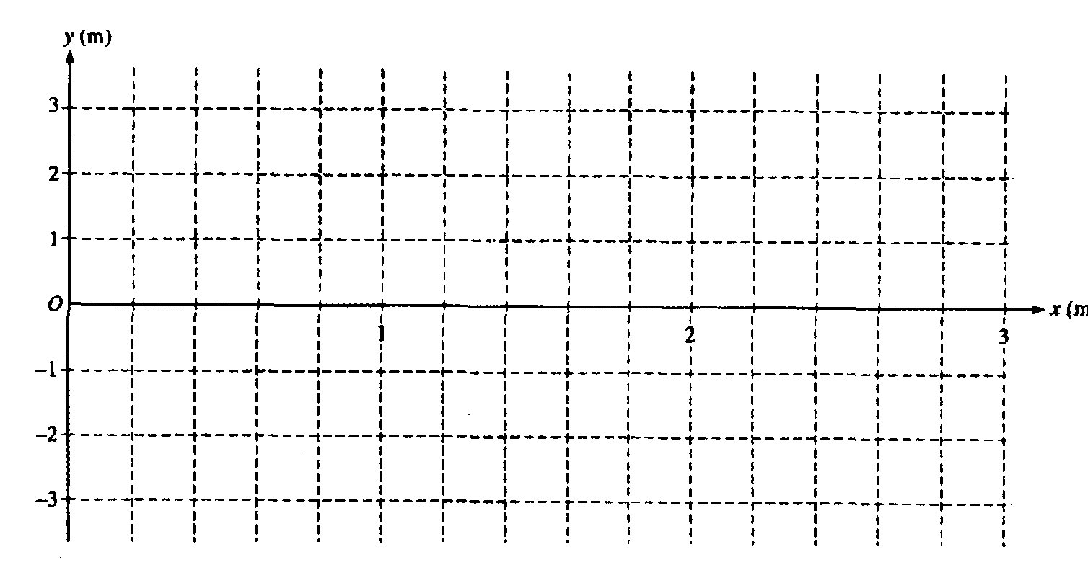
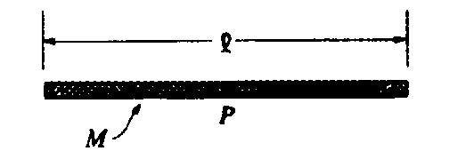
1996M3. Consider a thin uniform rod of mass M and length l, as shown above.

a. Show that the rotational inertia of the rod about an axis through its center and perpendicular to its length is Ml²/12 .

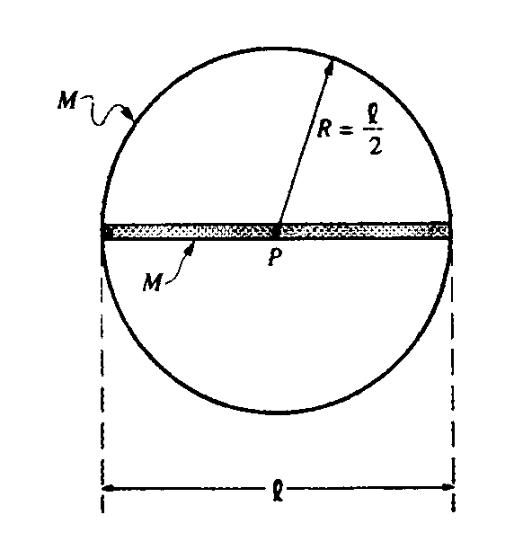
The rod is now glued to a thin hoop of mass M and radius R/2 to form a rigid assembly, as shown above. The centers of the rod and the hoop coincide at point P. The assembly is mounted on a horizontal axle through point P and perpendicular to the page.
b. What is the rotational inertia of the rod-hoop assembly about the axle?

Several turns of string are wrapped tightly around the circumference of the hoop. The system is at rest
when a cat, also of mass M, grabs the free end of the string and hangs vertically from it without swinging
as it unwinds, causing the rod-hoop assembly to rotate. Neglect friction and the mass of the string.
c. Determine the tension T in the string.
d. Determine the angular acceleration a of the rod-hoop assembly.
e. Determine the linear acceleration of the cat.
f. After descending a distance H = 5l/3, the cat lets go of the string. At that instant, what is the angular
momentum of the cat about point P ?

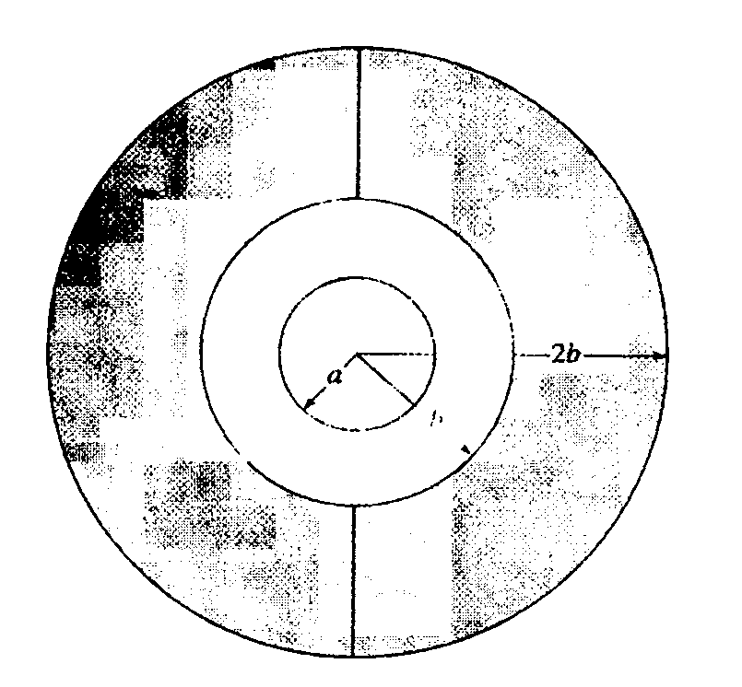

1996E1. A solid metal sphere of radius a is charged to a potential V_{o} > 0 and then isolated from the charging source. It is then surrounded by joining two uncharged metal hemispherical shells of inner radius b and outer radius 2b, as shown above, without touching the inner sphere or any source of charge.
a. In terms of the given quantities and fundamental constants, determine the initial charge Q_{o} on the solid sphere before it was surrounded by the outer shell.
b. Indicate the induced charge on the following after the outer shell is in place.
i. The inner surface of the shell
ii. The outer surface of the shell
c. Indicate the magnitude of the electric field as a function of r and the direction (if any) of the field for the regions indicated below. Write your answers on the appropriate lines.

i. r < a Magnitude Direction

ii. a < r < b Magnitude Direction

iii. b< r< 2b Magnitude Direction

iv. 2b < r Magnitude Direction

d. Does the inner sphere exert a force on the uncharged hemispheres while the shell is being assembled? Why or why not?
e. Although the charge on the inner solid sphere has not changed, its potential has. In terms of V_{o}, a, and b, determine the new potential on the inner sphere. Be sure to show your work.

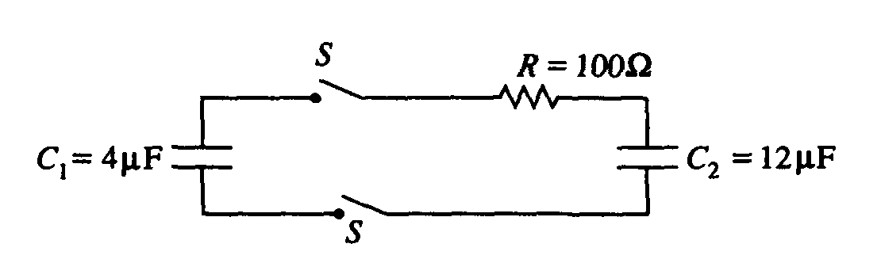

1996E2. Capacitors 1 and 2, of capacitance C₁ = 4μF and C₂ = 12μF, respectively, are connected in a circuit as shown above with a resistor of resistance R = 100Ω and two switches. Capacitor 1 is initially charged to a voltage V_{o} = 50 V, and capacitor 2 is initially uncharged. Both of the switches S are then closed at time t = 0.
a. What are the final charges on the positive plate of each of the capacitors 1 and 2 after equilibrium has been reached?
b. Determine the difference between the initial and the final stored energy of the system after equilibrium has been reached.
c. Write, but do not solve, an equation that, at any time after the switches are closed, relates the charge on capacitor C₁, its time derivative (which is the instantaneous current in the circuit), and the parameters V_{o}, R, C₁, and C₂.

The current in the resistor is given as a function of time by I = I_{o}e^{-t/τ}, where I_{o} = 0.5A and τ = 3 x 10⁻⁴s.
d. Determine the rate of energy dissipation in the resistor as an explicit function of time.
e. How much energy is dissipated in the resistor from the instant the switch is closed to when equilibrium is reached?

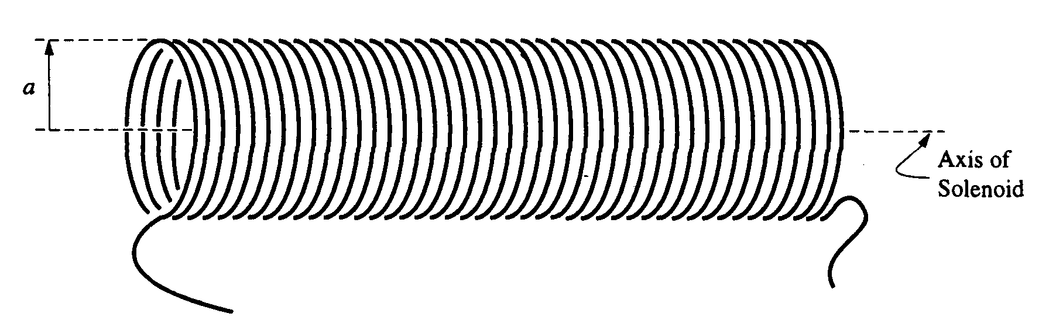

1996E3. According to Faraday's law, the induced emf E due to a changing magnetic flux φ_{m} is given by
E = 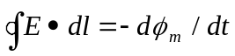, where E is the (induced) electric field and dl is a line element along the closed path of integration. A long, ideal solenoid of radius a is shown above. The magnitude of the spatially uniform magnetic field inside this solenoid (due to the current in the solenoid) is increasing at a steady rate dB/dt. Assume that the magnetic field outside the solenoid is zero.
a. For r < a, where r is the distance from the axis of the solenoid, find an expression for the magnitude E of the induced electric field in terms of r and dB/dt .
b. The figure below shows a cross section of the solenoid, with the magnetic field pointing out of the page. The electric field induced by the increasing magnetic field lies in the plane of the page. On the figure, indicate the direction of the induced electric field at the three labeled points, P₁, P₂ ,and P₃

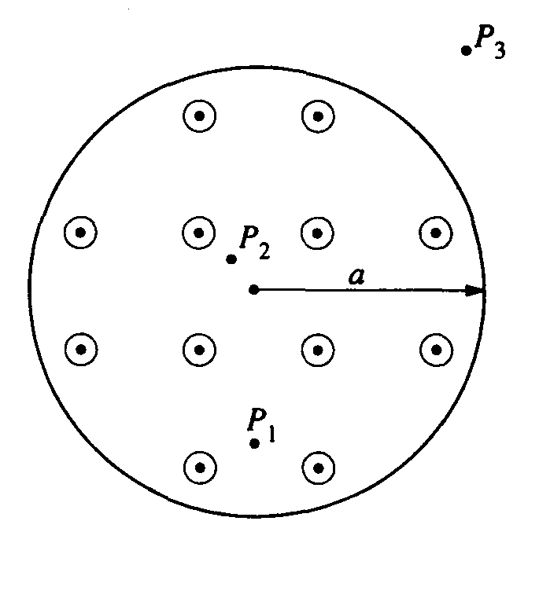
c. For r > a, derive an expression for the magnitude E of the induced electric field in terms of r, a, and dB/dt.
d. On the axes below, sketch a graph of E versus r for 0 ≤ r ≤ 3a.
